 | 13.1.12 Editors - Shader Editor - Header - Add Menu - Converter
Table of content
Detailed table of content 1
Add menu - Converter 5
Blackbody 5
Clamp 5
Color Ramp 6
Combine HSV 8
Combine RGB 8
Combine XYZ 8
Float Curve 9
Map Range 10
Math 11
RGB to BW 12
Separate HSV 12
Separate RGB 12
Separate XYZ 13
Shader To RGB 13
Vector Math 14
Wavelength 15

Detailed table of content
Detailed table of content
Detailed table of content 1
Add menu - Converter 5
Blackbody 5
Inputs 5
Temperature 5
Outputs 5
Color 5
Clamp 5
Inputs 5
Value 5
Min 5
Max 6
Properties 6
Clamp Type 6
Min Max 6
Range 6
Outputs 6
Result 6
Color Ramp 6
Inputs 6
Factor 6
Properties 6
Color Ramp 6
Controls 6
+ 6
- 6
Tools menu 6
Flip Color Ramp 6
Distribute Stops from Left 7
Distribute Stops Evenly 7
Eyedropper (pipette icon) E 7
Reset Color Ramp 7
Color Mode 7
RGB 7
HSV/HSL 7
Interpolation 7
Ease 7
Cardinal 7
Linear 7
B-Spline 7
Constant 7
Color Ramp 7
Active Color Stop elements 7
Choose active color stop 7
Pos 7
Outputs 8
Image 8
Alpha 8
Combine HSV 8
Input 8
H, S and V 8
Output 8
Color 8
Combine RGB 8
Input 8
R, G and B 8
Output 8
Color 8
Combine XYZ 8
Input 9
X Y and Z 9
Output 9
Color 9
Float Curve 9
Inputs 9
Factor 9
Attribute 9
Properties 9
Curve Widget 9
Navigation elements 9
Zoom in and out 9
Tools 9
Reset View 9
Vector Handle 9
Auto Handle 9
Auto Clamped Handle 10
Extend Horizontal 10
Extend Extrapolation 10
Reset Curve 10
Map Range 10
Inputs 10
Value 10
From Min 10
From Max 10
To Min 10
To Max 10
Properties 10
Interpolation Type 10
Linear 10
Stepped Linear 10
Smooth Step 10
Smoother Step 11
Clamp 11
Outputs 11
Result 11
Math 11
Inputs 11
Value 11
Value 11
Properties 11
Operation 11
Clamp 11
Outputs 12
Value 12
RGB to BW 12
Inputs 12
Image 12
Outputs 12
Value 12
Separate HSV 12
Input 12
Color 12
Output 12
H , S and V 12
Separate RGB 12
Input 13
Image 13
Output 13
R, G and B 13
Separate XYZ 13
Input 13
Vector 13
Output 13
X, Y and Z 13
Shader To RGB 13
Inputs 14
Shader 14
Outputs 14
Color 14
Alpha 14
Vector Math 14
Inputs 14
Vector 14
Vector 14
Scale 14
Properties 14
Operation 14
Outputs 14
Vector 15
Value 15
Wavelength 15
Inputs 15
Wavelength 15
Outputs 15
Color 15

Add menu - Converter
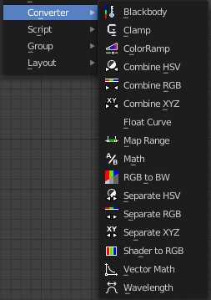
Here you find mainly nodes to convert data to another data.

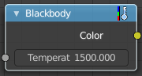
Blackbody
The Blackbody node converts a blackbody temperature to RGB value. This can be useful for materials that emit light at natural occurring frequencies.

Inputs

Temperature
The temperature in Kelvin.

Outputs

Color
RGB color output.

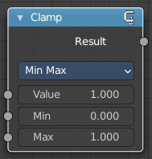
Clamp
The Clamp node clamps a value between a minimum and a maximum.

Inputs

Value
The input value to be clamped.

Min
The minimum value.

Max
The maximum value.

Properties

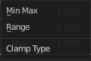
Clamp Type

Min Max
Clamp values using Min and Max values.

Range
Clamp values between Min and Max range.

Outputs

Result
The input value after clamping.

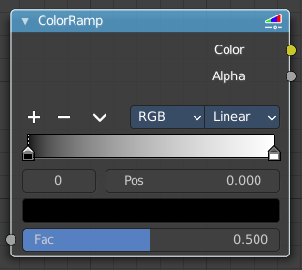
Color Ramp
The Color Ramp Node is used for mapping values to colors with the use of a gradient.

Inputs

Factor
The Factor input is used as an index for the color ramp.

Properties

Color Ramp
Color Ramps enables the user to specify a range of colors based on color stops. The color between the color stops gets interpolated.

Controls

+
Add a stop to your color ramp. The stop will be added after the selected one, in the middle to the next one.

-
Deletes the selected color stop from the list.


Tools menu

Flip Color Ramp
Flips the gradient, inverting the values of the color ramp.

Distribute Stops from Left
Rearrange the stops so that every step has the same space to the right.

Distribute Stops Evenly
Space between all neighboring stops becomes equal.

Eyedropper (pipette icon) E
An Eyedropper to sample a color or gradient from the interface to be used in the color ramp.

Reset Color Ramp

Resets the color ramp to its default state.

Color Mode

RGB
Blends color by mixing each color channel and combining.

HSV/HSL
Blends colors by first converting to HSV or HSL, mixing, then combining again. This has the advantage of maintaining saturation between different hues, where RGB would de-saturate, this allows for a richer gradient.


Interpolation

Ease
Uses an Ease Interpolation for the color stops.

Cardinal
Uses a Cardinal Interpolation for the color stops.

Linear
Uses a Linear Interpolation for the color stops.

B-Spline
Uses a B-Spline Interpolation for the color stops.

Constant
Uses a Constant Interpolation for the color stops.

Color Ramp
The color band. A click at one of the color stops makes it the active one. You can move the color stops by clicking at them and dragging them around.

Active Color Stop elements

Adjust the active color stop.

Choose active color stop
Choose the color stop by index.

Pos
The position of the active color stop. The range goes from 0.000 to 1.000

Outputs

Image
Standard image output.

Alpha

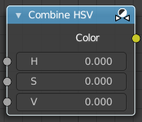
Combine HSV
Combine the single HSV channels into a single image.

Input

H, S and V
The Hue, Saturation and Value channels of an image.

Output

Color
Color output.

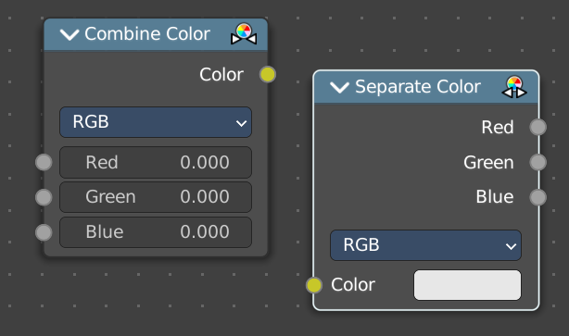
Combine Color
Combine the single RGB channels into a single image.

Input

Mode
- RGB colour processing
- HSV colour processing
- HSL colour processing

R, G and B
The red, green and blue channels of an image.

Input – RGB mode

R, G and B
The red, green and blue channels of an image.

Input – HSV mode

H , S and V
The Hue, Saturation and Value channels of an image.

Input – HSL mode

H , S and L
The Hue, Saturation and Luminescence channels of an image.

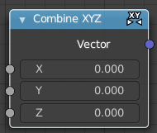
Combine XYZ
Same as with Combine RGB node. It combines color values. But instead combining rgb values, which are in the range of 0 to 255, it uses values in the range from 0 to 1.

Input

X Y and Z
X, Y and Z values.

Output

Color
Color output.

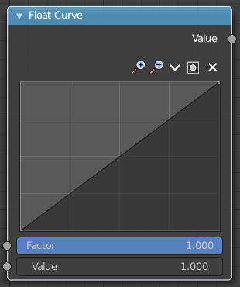
Float Curve
Generates a curve. This curve can then be used for profiles for example.

Inputs

Factor
The input factor.

Attribute
The input value.

Properties

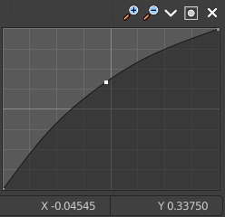
Curve Widget

Navigation elements
The navigation elements at the top are described from left to right.

Zoom in and out
The two buttons with the magnifying glass at it zooms in and out in the curve window.

Tools
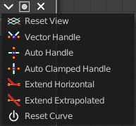
Tools is a menu where you can find some curve related tools.

Reset View
Resets the curve windows zoom.

Vector Handle
Set handle type to Vector.

Auto Handle
Set handle type to Auto.

Auto Clamped Handle
Set handle type to Auto Clamped.

Extend Horizontal
Extends the curve before the last point and after the last point horizontally.

Extend Extrapolation
Extends the curve before the last point and after the last point extrapolated.

Reset Curve
Resets the curve to the initial shape.

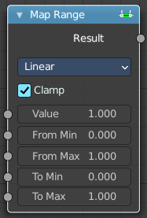
Map Range
The Map Range node remaps a value from a range to a target range.

Inputs

Value
The input value to be remapped.

From Min
The lower bound of the range to remap from.

From Max
The higher bound of the range to remap from.

To Min
The lower bound of the target range.

To Max
The higher bound of the target range.

Properties

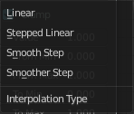
Interpolation Type

Linear
Linear interpolation between From Min and From Max values.

Stepped Linear
Stepped linear interpolation between From Min and From Max values.

Smooth Step
Smooth Hermite edge interpolation between From Min and From Max values.

Smoother Step
Smoother Hermite edge interpolation between From Min and From Max values.

Clamp
If enabled, the output is clamped to the target range.

Outputs

Result
The input value after remapping.

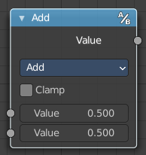
Math
The Math Node performs math operations.

Inputs

Value
First numerical value. The trigonometric functions accept values in radians.

Value
Second numerical value. This value is not used in functions that accept only one parameter like the trigonometric functions, Round and Absolute.

Properties

Operation
Here you can choose what mathematical operation to perform.
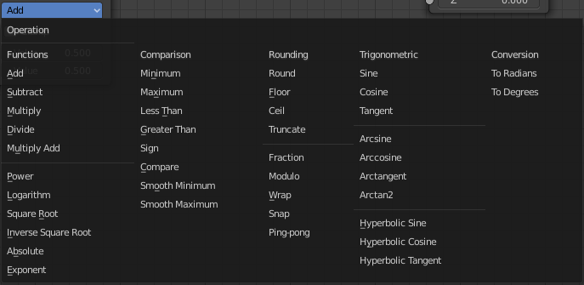

Clamp
Limits the output to the range (0 to 1). See clamp.

Outputs

Value
Numerical value output.

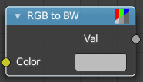
RGB to BW
The RGB to BW Node converts an RGB color image to a gray-scale image based at its luminance.

Inputs

Image
Color image input.

Outputs

Value
Gray-scale value output.

Separate Color
Separates the single RGB channels from a single image.

Input

Mode
- RGB colour processing
- HSV colour processing
- HSL colour processing

R, G and B

Image
The image input.

Output – RGB mode

R, G and B
The red, green and blue channels of an image.

Output – HSV mode

H , S and V
The Hue, Saturation and Value channels of an image.

Output – HSL mode

H , S and L
The Hue, Saturation and Luminescence channels of an image.

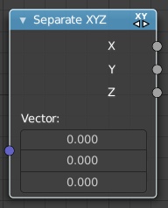
Separate XYZ
Same as with Separate RGB node. It separates color values. But instead separating rgb values, which are in the range of 0 to 255, it uses a vector with the values in the range from 0 to 1.

Input

Vector
The Input vector.

Output

X, Y and Z
The output vectors for X, Y and Z

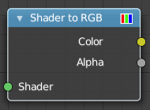
Shader To RGB
Eevee Only
Converts a shader input to rgba values.
The Shader to RGB node is typically used for non-photo realistic rendering, to apply additional effects on the output of BSDFs. For example, a color ramp on the output of a diffuse BSDF can be used to create a flexible toon shader.
Using this conversion breaks the PBR pipeline and thus makes the result unpredictable when used in combination with effects such as ambient occlusion, contact shadows, soft shadows and screen space refraction.
Some effects require multiple samples to converge, and applying arbitrary changes to noisy input may not convert to a smooth result.
Warning! If a Shader to RGB node is used, any upstream BSDF will be invisible to the following effects: Screen Space Reflection, Subsurface Scattering

Inputs

Shader
Any shader such as a BSDF or Emission node can be linked here.

Outputs

Color
Surface color computed from BSDFs and lighting.

Alpha
Alpha transparency from any Transparent BSDFs in the input.

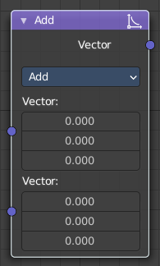
Vector Math
The Vector Math node performs the selected math operation on the input vectors.

Inputs
The inputs of the node are dynamic. Some inputs are only available in certain operations. For instance, the Scale input is only available in the Scale operator.

Vector
Input vector A.

Vector
Input vector B.

Scale
Input Scale.

Properties


Operation
The vector math operator to be applied on the input vectors.

Outputs
The output of the node is dynamic. It is either a vector or a scalar depending on the operator. For instance, the Length operator have a scalar output while the Add operator have a vector output.

Vector
Output vector.

Value
Output value.

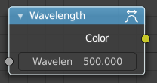
Wavelength
Cycles Only
The Wavelength node converts a wavelength value to an RGB value. This can be used to achieve a specific color on the light spectrum.

Inputs

Wavelength
The color wavelength from 380 to 780 nanometers.

Outputs

Color
RGB color output.

